Software Requirements Specification
For
Utility Store
Version 1.0 approved
Prepared by Suyog Arde
Veermata Jijabai Technological Institute
31 July 2017
Table of Contents
Table of Contents ii
Revision History ii
1. Introduction 1
1.1 Purpose 1
1.2 Document Conventions 1
1.3 Intended Audience and Reading Suggestions 1
1.4 Product Scope 1
1.5 References 2
2. Overall Description 4
2.1 Product Perspective 4
2.2 Product Functions 4
2.3 User Classes and Characteristics 5
2.4 Operating Environment 6
2.5 Design and Implementation Constraints 7
2.6 User Documentation 7
2.7 Assumptions and Dependencies 7
3. External Interface Requirements 9
3.1 User Interfaces 9
3.2 Hardware Interfaces 22
3.3 Software Interfaces 22
3.4 Communications Interfaces 22
4. System Features 23
4.1 System Feature 1 23
4.2 System Feature 2 24
4.3 System Feature 3 25
4.4 System Feature 4 26
4.5 System Feature 5 28
4.6 System Feature 6 29
4.7 System Feature 7 30
4.8 System Feature 8 31
4.9 System Feature 9 32
4.10 System Feature 10 34
4.11 System Feature 11 35

5. Other Nonfunctional Requirements 38
5.1 Performance Requirements 38
5.2 Safety Requirements 38
5.3 Security Requirements 38
5.4 Software Quality Attributes 38
5.5 Business Rules 5
6. Other Requirements 5
Appendix A: Glossary 5
Appendix B: Analysis Models 5
Appendix C: To Be Determined List 6

Revision History
Name | Date | Reason For Changes | Version

Introduction

1.1 Purpose
The purpose of the software requirement specification document is providing you with the detailed functionality of Utility Store. This document provides with additional information regarding the features of the system and also provides a view of how actually the system would look like. It also provides the information about the hardware, software and other resources used for developing the system. Thus it documentation will help the readers to logically understand and imagine the system working which will clear their doubts about the system.

1.2 Document Conventions
This document follows the standards of IEEE830. Bold-faced text has been used to emphasize section and sub-section headings. Highlighting is to point out words in that key and that may have its description in the appendixes. Specific Text is used to label and recognize diagrams. Various technical terminologies are used in this document and users may not get it while reading. So for additional information please check the appendixes and reference.

1.3 Intended Audience and Reading Suggestions
This system documentation is intended for the students which are the end users who are studying in VJTI and also other customers and development teams. Readers who want to have a detailed description of the system can go through the entire document till section 4.Readers those are only interested in the features and system specification can go through the section 3 and 4.Readers that need additional knowledge and verify the content can go through the references section. For developers please go through the entire document from 3 sections onward and read it briefly.

1.4 Product Scope
The concept of this system is quite clear that it is only meant to be implemented on the campus level of VJTI. All the students in the campus can be the users of the system. Students usually tend to sell their used accessories to a shop keeper, where they get very low price for their product, similarly the students who buy used accessories from the stores has to pay a very high price. Difference between selling and buying price is high, this is due to profit margin of the shopkeepers. Thus to avoid this scenario the utility store allows the students to sell their accessories through the utility store and as well as buy from the utility store. The utility store just acts as platform without profit and allows users to buy and sell their products at reasonable prices without any drastic loss.

1.5 References
https://cs.gmu.edu/~dfleck/classes/cs421/spring08/SampleProject/FINAL%20SRS.pdf

https://www.cise.ufl.edu/class/cen3031sp13/SRS_Example_1_2011.pdf

https://www.olx.in/

https://cs.gmu.edu/~dfleck/classes/cs421/spring08/SampleProject/FINAL%20SRS.pdf

2.0 Overall Description

2.1 Product Perspective
The Utility store is a web based platform structured on client server model that allows the students of VJTI to sell and buy used college accessories online through the utility store. The products that they can advertise should specify certain terms and condition, the constraints allow filtering out unwanted products saving users valuable time. Once the product satisfies the standards the seller can post the latest photo of the product with certain description and features. The sellers have to also provide their personal details so that buyers can communicate with them. Buyers don't have any rules to follow, provided they are students of VJTI. The buyers can have access to various products depending on the category that has been selected by them. The server in this system acts as a record holder for information provided by the users about them and their products.

2.2 Product Functions
The Utility store provides various functions and the function are listed based on their priorities.

- User Authentication and registration.
1. Allows the user to authenticate itself by providing the required details.
2. Allows the user to customize his or her profile.

- Uploading Ads:-
1. Users can upload their ads that are their product photos and enter product descriptions.
2. Users can select the category that their products fit in.

- Modifying Ads:-
- Users if required can modify their ads that are they want to change the price at which they are selling.
- Users can modify certain additional information regarding the product that they forgot to mention earlier or add a latest image of the product.

- Ad Removal:-
- In case after few days user thinks that he/she needs the product and should not sell it then; he/she can withdraw the product by removing the ad.

- Pay:-
- If a buyer likes a product and is interested in buying it then he can either buy the product from the seller using the payment option such paytm or any other and also can book the product and then contact the seller through the number provided and then can pay for the product in cash through one to one interaction.
- Contact us:-
- In case users feel that the product is not adequate or such kinds of product should not be displayed , that he/she can contact us through the form available and his/her grievances shall be taken into consideration.
- Users can also provide us with any innovative ideas that they think can be implemented in the system that can enhance its working.

- Help:-
- Clarification about most of the basic doubt arising among the individuals will be clarified in question and answer format.
- It also includes video tutorial which will help the first time users to get used to how actually the system.
- The tutorial will describe how to post ads, how to write the descriptions and what details should be included while posting the ads.
- The tutorial will describe how users can buy the products and how can they contact the sellers.

- Add to cart:-
- Buyers can add the items to the cart that they would like to buy.
- Add to cart option allows checking item that you have shortlisted reducing the time to search for the similar product again.

- Setting:-
- The setting tab allows the users such as admins, buyers and sellers to update their personal information’s, their passwords.

2.3 User Classes and Characteristics
- Users:-
- Any student who wants to be a member of the utility store has to first sign up in the system by entering his or her personal details, email id and college id are mandatory and the students have to set a strong password to their account.
- To get the complete benefits of the system the users need to login from their account and perform the task he/she wants on the system.
- Depending on the task we can divide the users into 2 types:-
- Sellers
- Buyers
- Sellers:-
- The users can get the feature of selling the goods only when they have logged in the system.
- The seller has access to features such as uploading the ads that is advertising the product that they want to sell, providing basic information regarding the product that they intend to sell such as its features, working and the days it is used and the price at which they intend to sell the product.
- The seller also has access to feature such as modifying Ads where seller can modify their advertisement that they have posted earlier. They can edit the description that was provided, its price, update the products photo or any detail related to the product.
- The seller if needed can even remove the advertisement posted; if he/she has changed her/his mind on that product.
- Buyer:-
- The users who intend to buy the product available at the Utility Store, i.e. they want to become a buyer can enjoy this feature only when they have logged in the system.
- The buyer who wants to buy a particular product can directly talk with respective seller; after talks if he/she is satisfied that they can buy the product from the seller.
- The place from where you buy and mode will be decided by the users only; system is not involved in this process.

- Features of General Users:-
- They can have access to various products available online through the system.
- They can report if certain products that are made available are not suitable to be sold on the store.
- Any new ideas or new enhancement that they want us to add can conveyed through the contact us form available to the users.
- Can use the help option provided to get answer to some questions about the system.

- System Administrator:-
- The system administrator is the person that keeps track of all the data that has been stored in the system.
- The administrator also does the job of filtering out the contents that are being uploaded in the system.
- The administrator also test working of the system to make sure that the system is working properly.
- The administrator also looks after the rights that are given to the user and verifying their authenticity.

2.4 Operating Environment
The Utility Store is a web based application that works on the client server model where clients are the users that are accessing the website through their respective devices connected to internet and server is the machine where all the files related to the website are stored and where all the data regarding the users and other aspects of the system are stored. The User Interface will be developed using bootstrap and some other web designing languages and backend of the system will develop PHP 5 to ensure efficient functioning of the system. The website will be hosted on the free hosting as 000webhost.com and database used for store will be MySQL. The website will be supported by all the web browsers available.
The UI will user friendly and lite and will work on the devices with minimum 512 Mb ram. The server requirements will probably be a device at least 2 GB ram and 500 GB storage. No other hardware or software requirement is required for this application.

2.5 Design and Implementation Constraints
The Utility Store is web based system that means it should device independent as well operating system independent; achieving device independency will be a difficult task that is to make sure that website will be responsive on any device that it is used. Making the UI friendly lite is another constraint as to decrease the loading time. Since fetching images from database and displaying it without any error is heavy weight process and is most difficult constraint. Implementing the real time chat is only one of the constraints while designing. Utility Store is meant to be quick and responsive, even when dealing with large data, so each feature must be designed and implemented with efficiency in mind and making sure that system would be accessible to most of the device having minimum ram of 512 MB.

2.6 User Documentation
The Utility Store basically is a platform for buying and selling used college accessories. New users will find it difficult to how to navigate to the system and how actually perform tasks such as buying and selling, to make their job easy we have provided to options for the users which Utility Store tutorials and help.
The tutorials demonstrate things such as how to registers, what data needs to be feed and how to set password. Then it also demonstrated exactly how to post an advertisement, how to add description and price and how to update advertisement, it also demonstrate how to buy the products, that is how to get the details of seller.
The help option provides you with the frequently asked questions and with their respective answers, if the question you needed if not available then the users can contact us through the contact tab provided to solve their doubts.

2.7 Assumptions and Dependencies
2.7.1 Time Dependencies:-

The features that listed in the section 2.2 are based on their priorities and all the features come under the core. But what shall we implemented first is decided by the priority attached to each of the features. No optional features are currently being provided , if any suggestion or need as so is arrived in the future then it can implemented in the new version of the system, but currently the listed shall only be provided with in the given period.

2.7.2 Hardware Dependencies:-

The hardware dependency is just that the system should be connected to internet and should have minimum ram of 512 MB.

2.7.3 Software Dependencies:-

The system should have any web browser available from Google chrome to Internet Explorer .To support network connectivity.

3.0 External Interface Requirements

3.1 User Interfaces

3.1.1 Home Page:-

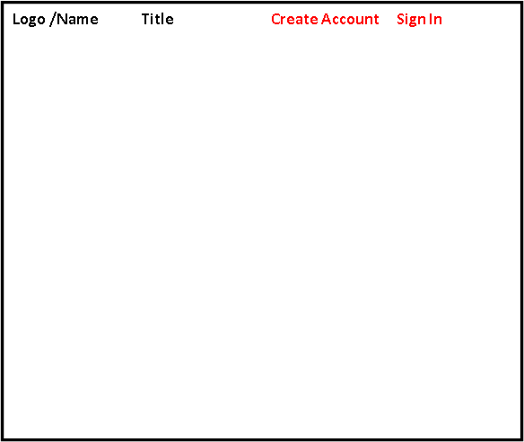
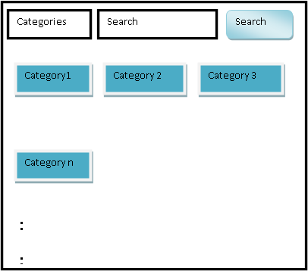
Logo/name
Help
Who are we?
Connect with us
Contact Us
Terms and Condition’s


:
:
:

Categories
Search
Search
Category1
Category 2
Category 3
Category n

- The home consist of the logo the system in the top left with the name of the system in the middle with the options for the users to create an account if it does not exists previously or to sign in to the existing account.
- The Middle options consist of the category select option with the search options for typing the name of the product that the user wants to search.
- Then below it we have the categories in order to have a direct access to the specific category.
- The bottom part of the page consist of the basic functionalities such as contact us, terms and conditions, social media connect to options.

3.1.2 Register Page:-
Register
Register
Name:-
ID:-
Department
Phone Number
Email ID
Password
Confirm Password

- The register allows the non-existing user to have complete access to the system by providing his/her personal details and create his individual login to the system.
- The system wants the user to enter their personal details like email id, department, year, id, and name and set a password to the account too.

3.1.3 Login:-

Login
Submit
Email ID
Password

- User once registered can login to the system through his/her email id and password.
- After verifying the details provided as email id and password, the users are directed to their homepage.

3.1.4 Search Product:-

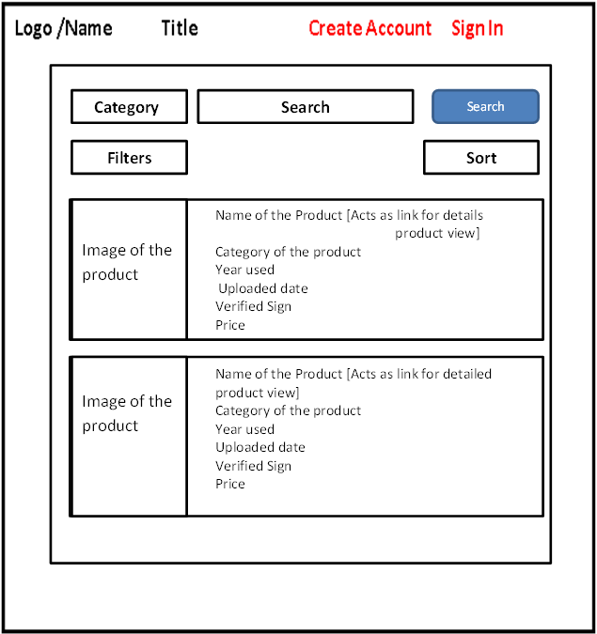

The search product function allows the users to the products that are available in the systems.
- The user first has to select the category, followed by the searching text and has to press the search button, to display the related products.
- The category allows more accurate search results.
- The user can also filter the contents that are the price range that he /she want.
- The users can sort the products either in ascending or descending order of the price.
- The search result appear as shown in the middle section that is with the product image and short details about the product

3.1.5 Detailed Product Description:-

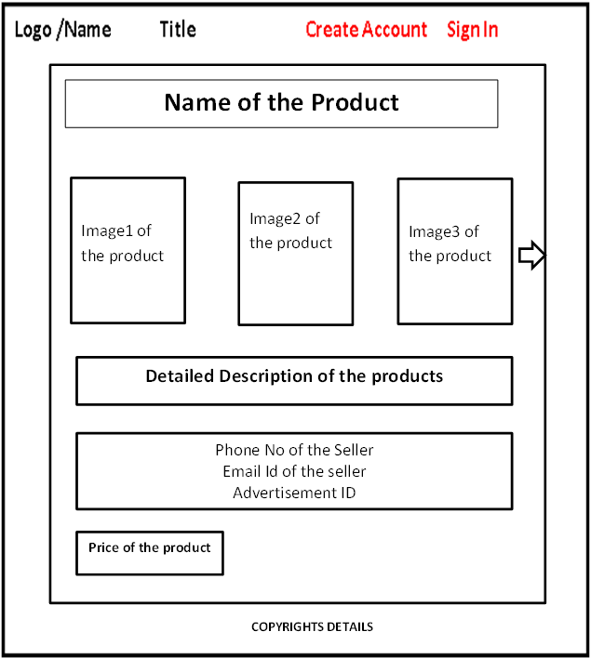

The detailed product description can be accessed by click on the product.
- The product detailed description consists of the Name of the product, multiple images of the products.
- Detailed information about the product.
- The details about the seller.
- The price of the product.

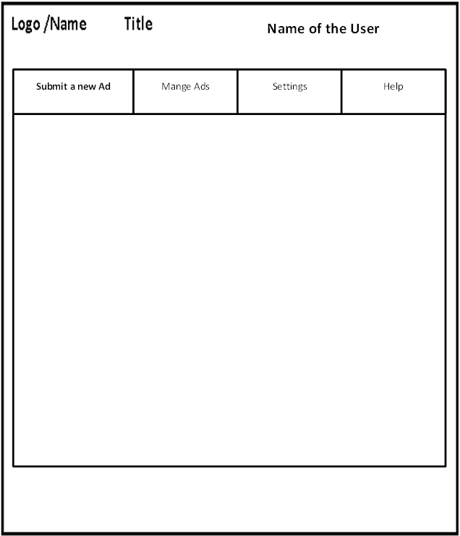
3.1.6 Logged in Webpage:-

Once the user is logged in the system, he is directed to the above page.
- The webpage consist of the options that are available for users such as selling the product by uploading ads, managing the ads, setting which include editing his personal details and also help option specifically for the new users or users who have used the system after long time.

3.1.7 Submit a new Ad tab:-

Title
Category
Years used

Ads Description:-

Upload Photos
Phone Number

Price

Upload an AD
Submit
Copyrights Details

This tab allows the user to advertise the product that he/she wants to sell.
- The details that the users should fill for uploading the ads are given in the pictures, all the fields and mandatory.
- The users can multiple images of his/her product and cannot exceed 5 images per Ad.
- Title is the name of the product

3.1.8 Update Ad:-

Category:-
Description:-
Image:-
Years used:-
Price:-

Update Ad
Delete Ad
Payment
Help
Submit
Name of the user

- The update ad functions allow the user to update the details of his ads such as the price, category and descriptions.
- This function allows the users to upload the latest images of the product.

3.1.9 Delete Ad:-

Copyrights Details
Name of the Users
Update Ad
Delete Ad
Payment
Help
Name of the Product
Category
Years used
Short Description
Price
Image of the product
Delete
Name of the Product
Category
Years used
Short Description
Price
Delete
Image of the product

If a user does not want to sell the product that he has advertised and has the rights to remove the product by deleting the product.

3.1.10 Payment:-
Title
Category
Advertisement ID:-
Price
Phone:-
Payment Mode:-[Cash/PayTm]

Submit
Image of Product
Copyrights Details
Name of the Users

- This function allows the users to pay for the product that they want to buy either through payTm or through cash.
- The user is also send an invoice if an online transaction occurs.
- For payment of the product in cash users can book the product and has to pay for it within 1 week.

3.1.11 Help:-
Update Ad
Delete Ad
Payment
Help
FAQ No 1
FAQ No 2
FAQ No N
You can also contact us at Some@emailid

Copyrights Details

The Help tab provides details about which problem usually the users have and how to solve those problems.

3.1.12 Setting:-
Logo/Name
Title
Name of the User
Submit a new Ad
Manage Ads
Settings
Help
Update Profile
Change Password
Delete Account

- The setting allows the users to update their profile, which includes his/her Phone number, email id.
- The settings also allow the users to change their password which allows the user to set a new password for his accounts.
- The settings allow the users to delete his account if he no longer needs the system.

3.1.13 Filter:-

Copyrights Details
Logo/Name
Title
Name of the user

Category
Search
Filter
Sort
Name of the product
Category
Upload date
Years Used
Verified Sign
Price

Image of the product
Remove
Search

- Allows the admin to remove the unwanted ads.
- The seller whose ad is removed is notified.

3.2 Hardware Interfaces The Utility Store is a web based application and hence works on the client server model. From user’s point of view what matters is client which is here a hardware interfaces that can include a pc or a laptop or a mobile so that users can access the webpage of the utility. The client may also have functional hardware for entering the data that might be a keyboard and mouse for clicking such requirement do not compile to smart phones.

3.3 Software Interfaces The software interfaces here include a web browser through which you can access the webpage of utility store .The payTM API for payment of the products .Using Mail Chimp or the basic SMTP connect for sending email notification to the users. Then we have way2SMS for sending the SMS notication.

3.4 Communications Interfaces
The HTTPS protocol will be used by Utility Store for higher security over the internet. Then we use the basic TCP/IP protocol for sending the data within a network.

4.0 System Features
4.1 Registration

4.1.1 Use case Name: - Registration
4.1.2 Brief Description: -
The registration feature allows the user to enter the required details in the form given. The details are required to create a unique account for the user with his unique id and password.
4.1.3 Actors Involved: - Sellers, Buyer.
4.1.4 Frequency, criticality and priority:-
Not so frequently used, code complexity is average and priority is highest.
4.1.5 Pre-Condition:-The user has to visit the official webpage of the system where the form for account creation is available.
4.1.6 Basic Flow Event:-
Actors | System
- The actors enter the required details include Name, Age, home address, gender, DOB, email id and unique strong password.
 | - The system validates the data provided by the user.
 | - The system inserts the user entry into the database.
 | - The System sends a notification to the user that “Successfully registered”.

4.1.7 Alternate Flow of Event:-
2.1 The actors get error to “To re-enter the data “if the information was incorrect.
2.2 The actors get error to “To fill all the mandatory fields” if all the fields are not filled.
3.1 The actors may get error such as “Unable to connect to database, please try again”.
3.2 The actors get an error unable to create an account, please try again.
4.1.8 Post Condition:-
User is redirected to login page.
4.1.9 Special Conditions:-
The system access time should be very less.
4.2 Sign in:-
4.2.1 Use case Name: - Sign in
4.2.2 Brief Description: -
The user logs into the system with the provided unique email id and password.
4.2.3 Actors Involved: - Sellers, Buyer, and admin.
4.2.4 Frequency, criticality and priority:-
Frequently used, with average complexity and high priority since users are logged through this module.
4.2.5 Pre-Condition:-The user must have signed up in the system and loaded the login page.
4.2.6 Basic Flow Event:-
Actor | System
- The sellers or buyers logins through the user id and password provided earlier.
 | - System validates the data.
 | - System authenticates the data with that stored in database.
 | - The system redirects the users to home page.
- The user gets access to his home page.

4.2.7 Alternate Flow of Event:-
2.1 The actors get error to “To re-enter the data “if the information was incorrect.
2.2 The actors get error to “To fill all the mandatory fields” if all the fields are not filled.
2.3 The actors may get error such as “Make sure right you’re ID and Password is correct”.
3.1 The actors get an error “Unable to connect, please try again”.
4.2.8 Post Condition:-
The user is logged in to the system. The user has access to the functions of the system.
4.2.9 Special Conditions:-
The system access time should be very less.
4.3 Upload Product Ads:-

4.3.1 Use case Name: - Upload product Ads
4.3.2 Brief Description: -
The seller can upload the images of the product that they want to sell and the product description that the seller wants to add such as product name, price, for how long it is used.
4.3.3 Actors Involved: - Sellers.
4.3.4 Frequency, criticality and priority:-
Frequently used, with high complexity and high priority since sellers used it frequently for selling out their products.
4.3.5 Pre-Condition:-The user must have signed up in the system.
4.3.6 Basic Flow Event:-
Actor | System
- The user selects the submit new ad tab.

 | - Page for submit new ad.
- User uploads the Image of the product
- Enter the title, category, description, price, years used, phone number.

 | - The System validates the data provided by the user.
 | - The system creates an entry of the Ad in the database.
 | - System sends notification “Ad successfully uploaded”.

4.3.7 Alternate Flow of Event:-
  - The actors get error to “Please make sure that the size of the image is less than 2 MB”.
  - The actors get error “Please enter the data correctly”.
  - The actors get error to “To fill all the mandatory fields” if all the fields are not filled.
6.1 The actors may get error such as “Unable to connect to database, please try again”;
6.1 The actor gets error such as “Server Down”.
4.3.8 Post Condition:-
The user has access to the select the upload Ad tab in the system.
4.3.9 Special Conditions:-
The system access time should be very less.
4.4 Modify Product Ads
4.4.1 Name: - Modify Product Ad
4.4.2 Brief Description: - The modify product Ad allows the seller to modify the details of the ads such as the product photo, product description, product prices etc.
4.4.3 Actors Involved: - Seller
4.4.4 Frequency, Priority and Criticality:-
The use case is used every time a seller has product ads, it has average priority and the complexity of code is average.
4.4.5 Pre-Condition:-
The seller must have logged in the system and has a verified product ad uploaded.
4.4.6 Basic Flow Event:-
Actor | System
- The user selects the Manage Ad tab.

 | - The tab is loaded on the users device
- The user selects the Update Ad tab.

 | - The tab is loaded on the user’s device with images of uploaded Ads.
- The user clicks the ad he wants to update.
 | - Update Ad page appears
- The user enter the details such as the category, years used, price, images, description.

 | - System validates the data entered by the users.
 | - System updates the Ads entry stored in database.
 | - The system sends a notification “Ad successfully updated”.

4.4.7 Alternate flow of Event:-
8.1 The actors get error to “Please make sure that the size of the image is less than 2 MB”.
8.2 The actors get error to “To fill all the mandatory fields” if all the fields are not filled.
8.3 The actor gets error “Please make sure right data is entered”.
9.1 The actors may get error such as “Unable to connect to database, please try again”;
9.2 The actors get an error “Server down pleases try again.
4.4.8 Post –Condition:-
The modification done to the ad is legitimate.
4.4.9 Special Condition:-
The action should be performed within in 15 minutes.
4.5 Remove Ads:-

4.5.1 Name: - Remove Ads.
4.5.2 Description: - The remove ads allow the seller to remove the ads that are no longer required or the product has been sold out.
4.5.3 Actors Involved: - Seller
4.5.4 Frequency, Priority and Criticality:-
The use case is used every time a seller has product ads, it has average priority and the complexity of code is average.
4.5.5 Pre-Condition:-
The seller must have logged in the system and has a verified product ad uploaded.
4.5.6 Basic Flow of System:-
Actor | System
- The user select Manage ad Tab.
 | - The tab is loaded on the user’s device.
- The user selects the delete ad option.

 | - The tab is loaded with the Ads Image and Short Description and delete button
- The user click on the delete button.
 | - The system pops a dialog box for confirmation.
- The user clicks “yes” button.
 | - The system deletes the entry of the Ad from the database.
 | - The system sends a notification “Ad successfully deleted’.

4.5.7 Alternate Flow of Events:-
7.1 The actors click “No” then the flow break.
8.1 The actors may get error such as “Unable to connect to database, please try again”;
8.2 The actors get an error “Server down pleases try again”.
4.5.8 Post –Condition:-
The actor will not see the delete ad.
4.5.9 Special Condition:-
The action should be performed within in 15 minutes.
4.6 Add to cart:-
4.6.1 Name: - Add to cart.
4.6.2 Brief Description: - The add to cart allows the buyers to add the products to the cart that he wants to buys or would like to buy.
4.6.3 Actors Involved: - buyers.
4.6.4 Frequency, Priority and Criticality:-
The use case is used often when the buyers like any product, criticality is average and priority is average.
4.6.5 Pre-Condition:-
The seller must have logged in the system.
4.6.6 Basic Flow of Event:-
Actor | System
- The buyer searches from the ads available using the search textbox.

 | - Ads related to the search are loaded in grid.
- Buyer ads the ads he likes by clicking the ad to cart option available on the Ad
 | - Product successfully added to your cart.

4.6.7 Alternate Flow of Events:-
1.1 The actor gets error “product searched is not available”.
4.1 The actors get error to “Unable to add the ad to the cart, please try again”.
4.6.8 Post –Condition:-
The buyers cannot add more than 3 products to the cart.
4.6.9 Special Condition:-
The action should be responsive.
4.7 Search:-
4.7.1 Name:-Search.
4.7.2 Description:-Allows the sellers, buyers, admin to the search the products.
4.7.3 Actors Involved: - Sellers, buyers, admin all can search the products.
4.7.4 Frequency, Priority and Description:-
The mostly widely used feature, high priority and criticality are average.
4.7.5 Pre-Condition:-
User should have loaded the home of Utility Store.
4.7.6 Basic Flow of Event:-
Actor | System
- The buyer searches from the ads available using the search textbox.
 | - System retrieves the Ad related to the search from database.
 | - System displays the Ads in grid.
4.7.7 Alternate Flow of Events:-
  - The actor gets error “product searched is not available”.
  - The actor gets error “unable to connect to database”.
  - The actor gets error “the server is down, please trying again”.
3.1 The system displays nothing.
4.7.8 Post –Condition:-
The product is not available.
4.7.9 Special Condition:-
The action should be responsive.
4.8 Help:-
4.8.1 Name:-help
4.8.2 Description: - Provides video tutorials explaining the working of the system, FAQ and their answers.
4.8.3 Actors Involved: - Sellers, buyers, admin.
4.8.4 Frequency, Priority and Description:-
The mostly widely used feature, high priority and criticality are average.
4.8.5 Pre-Condition:-
User should have logged in.
4.8.6 Basic Flow of Event:-
Actor | System
- The user click on the Help Tab

 | - The page is loaded on the users device with options such as videos and FAQ
- The user can then select either of it

 | - Respective page appears.

4.8.7 Alternate Flow of Events:-
  - if actor gets videos then:-
    - The videos page is loaded.
    - The user can click on the video that he wants to see to understand the working.
3.1.2.1 The user gets an error unable to play the video, please again.
3.2 If the actor selects FAQ:-
3.2.1 The videos FAQ is loaded.
3.2.2 The user can click on the question whose answer he wants to know.
4.8.8 Post –Condition:-
None
4.8.9 Special Condition:-
The most of the FAQ should be answered and response time should be minimum.
4.9 Payment:-
4.9.1 Name: -Pay
4.9.2 Description: - Allows the payment for the product that the buyers want to buy.
4.9.3 Actors Involved: - Seller and buyer.
4.9.4 Frequency, Priority and Criticality:-
It is used when the buyer wants to buy a product, high priority and criticality high.
4.9.5 Pre-Condition:- The actor should be logged in.
4.9.6 Basic Flow of Event:-
Actor | System
- The buyer searches from the ads available using the search textbox.
 | - System retrieves the Ad related to the search from database.
 | - System displays the Ads in grid
- The actor can then click the product he wants to buy.
 | - A new page showing product details appear.
- The buyer click on the buy button.
 | - The buyer is redirected to page to confirm mode of payment.
- The buyer can either book the product then pay through cash to the user or the buyer can use the payment gateway feature such as payTM.
 | - System asks for confirmation.
- User clicks yes.
 | - The entry regarding the payments details and seller and buyer is stored in database.
 | - The systems send mail to sender and receiver regarding the product and transaction details.
 | - The system displays a pop up “Transaction Successfully “.

4.9.7 Alternate flow of event:-
  - The actor gets error “No related product available”.
  - The actor gets error “Not able to connect to Database”.
  - The System displays nothing.
6.1 The actor gets an error “The product is currently booked”.
8.1 If actor selects booking
8.1.1 Actor should buy the product within one week.
8.2 If actor selects payments
8.2.1 The actor is redirected to API page.
8.2.2 The actor enters the phone number of the Seller available.
8.2.2.1 The system checks whether seller has payTM account.
8.2.2.2.1 If no then cancel the transaction “Please opt for booking”.
8.2.2.2.2 If yes then validate transaction.
10.1 if No then cancel the transaction, rollback.
11.1 The system is unable to connect to database please try again
11.2 The server is down try again later.
12.1 Email notification failed, you will be notified soon.
4.9.8 Post-Condition:-
The product should be delivered within a given period of 1 week.
4.9.9 Special Condition:-
Rollback if the transaction is not completed.
4.10 Filter:-
4.10.1 Name: - Filter.
4.10.2 Brief Description: - The admin has the rights to delete a product that he fills is not valid and should not be sold such products can be removed by the admin.
4.10.3 Actor: - Admin.
4.10.4 Frequency, Priority and Criticality:-
It is used when the admin to keep check on the system, high priority and criticality high.
4.10.5 Pre-Condition:- The actor should be logged in.
4.10.6 Basic Flow of Event:-
Actor | System
- The buyer searches from the ads available using the search textbox.
 | - System retrieves the Ad related to the search from database.
 | - System displays the Ads in grid
- The actor can then select the product he wants to check.
 | - A new tab showing product details appear.
- The actor can then delete the product that the things are a misfit.

 | - System asks for confirmation.
- User clicks yes.
 | - The entry of the ad is deleted from the database.
 | - The user who uploaded the ad is notified.
 | - The pop up appears “Product successfully removed”.

4.10.7 Alternate flow of event:-
  - The actor gets error “No related product available”.
  - The actor gets error “Not able to connect to Database”.
  - The System displays nothing.
8.1 If the admin says no, break the flow.
9.1 The system is unable to connect to database please try again
9.2 The server is down try again later.
10.1 Email notification failed, you will be notified soon.
4.10.8 Post-Condition:-
The products that are misfits should be available.
4.10.9 Special Condition:-
The sellers whose product is removed should be notified.
4.11 Setting:-
4.11.1 Name:-Setting
4.11.2 Description:-Allows the sellers, buyers, admin to the update his or her profile, password and delete the account if no longer needed.
4.11.3 Actors Involved: - Sellers, buyers, admin all can have access to the setting tab.
4.11.4 Frequency, Priority and Description:-
The mostly widely used feature, high priority and criticality are average.
4.11.5 Pre-Condition:-
User must have logged in the system.
4.11.6 Basic Flow of Event:-
Actor | System
- The user selects the Setting tab.

 | - The tab is loaded on the users device
- The user selects the one of the three options
1. Update Profile.
2. Update Password.
3. Delete account.

 | - The tab is loaded on the user’s device
- The user enters the information based on option selected
 | - The system validates the data from users.
 | - The system updates the database.
 | - The system displays a pop up “successfully done”.

4.11.7 Alternate Flow of Events:-
3.1 The user selected the update profile.
4.1 The update profile tab is loaded.
3.2 The user selected the update password.
4.2 The update password tab is loaded.
3.3 The user selected the Delete Account.
4.3 The delete account tab is loaded.
6.1 The system displays an error “Please fill all the fields”.
  - The system displays an error “Make sure correct data is entered”.
  - The actor gets error “unable to connect to database”.
7.2 The actor gets error “the server is down, please trying again”.
8.1 The system displays nothing.
4.11.8 Post –Condition:-
The data provided by user has been successfully stored.
4.11.9 Special Condition:-
The action should be responsive.

5.0 Other Nonfunctional Requirements

5.1 Performance Requirements
Since the Utility Store is a web based application it is necessary for the user to be connected to the requirement. As there are lot of images of large sizes the downloading speeds of the system will depend on the user’s devices and his internet speed. But we have tried to control and have the users max download speed of 3 to 4 seconds in worst scenario. For this purpose we have such efficient database technology and have used the efficient algorithms to generate quick responses.

5.2 Safety Requirements
The users are requested to ensure the quality of the product before they buy that is make payments. If users get a suspected response please contact the Utility Store through the help option provided we will take the necessary actions. User’s safety is our priority.

5.3 Security Requirements
The users are requested to not disclose their passwords to anyone if such thing happens please inform us through the help options. Users’ data and identity will be kept secret. All your transactions will be well protected.

5.4 Software Quality Attributes
The user interface of the system will be user friendly; it is indeed our priority make the ease of use for the users who have some or no technical information. The system is flexible that is responsive that it gets adapted to any screen that is used by the user. Users’ feedback will be given high importance regarding the upgrading of the system.

Appendix A: Glossary
SMS | Short Message Service
Database | A structured set of data held in a computer, especially one that is accessible in various ways
SQL | Structured Query Language
UI | User Interface - the means by which the user and a computer system interact, in particular the use of input devices and software
Checklist | A list of items required, things to be done, or points to be considered, used as a reminder.
Server | A server is a computer program that provides services to other computer programs (and their users) in the same or other computers
Payment Gateway | A payment gateway is a merchant service provided by an e-commerce application service provider that authorizes credit card or direct payments processing for e-businesses, online retailers, bricks and clicks, or traditional brick and mortar
Invoice | a list of goods sent or services provided, with a statement of the sum due for these; a bill.
RAM | Random access memory (RAM) is a type of data storage used in computers that is generally located on the motherboard. This type of memory is volatile and all information that was stored in RAM is lost when the computer is turned off
Processor | the part of a computer in which operations are controlled and executed
MB | Mega Bytes
KB | Kilo Bytes
Bytes | a group of binary digits or bits (usually eight) operated on as a unit.
OS | Operating System
MailChimp | MailChimp provides marketing automation for e-commerce businesses. Send beautiful emails, connect your e-commerce store, advertise, and build your brand.
Way2SMS | Way2SMS helps users to send SMS to any mobile in the country. Sending messages from Way2SMS is Free , easier, and personal; above all messages are delivered in just few seconds
PayTM | The Paytm Wallet application enables users to book air tickets and taxis, mobile recharge, and payment of DTH, broadband and electricity bills among others. The money transfer feature is only available for mobile users, not for desktop. Users can also pay for fuel at Petrol pumps and buy movie tickets at PVR Cinemas through the wallet.
PHP | PHP (recursive acronym for PHP: Hypertext Preprocessor) is a widely-used open source general-purpose scripting language that is especially suited for web development and can be embedded into HTML.
Bootstrap | Bootstrap is a free and open-source front-end web framework for designing websites and web applications. It contains HTML- and CSS-based design templates for typography, forms, buttons, navigation and other interface components, as well as optional JavaScript extensions. Unlike many web frameworks, it concerns itself with front-end development only.
HTML 5 | HTML5 is the latest evolution of the standard that defines HTML. The term represents two different concepts. It is a new version of the language HTML, with new elements, attributes, and behaviors, and a larger set of technologies that allows the building of more diverse and powerful Web sites and applications.
MySQL | MySQL is an open-source relational database management system. Its name is a combination of “My”, the name of co-founders Michael Widenius's daughter, and "SQL", the abbreviation for Structured Query Language.
000webhost.com | Free web hosting website.

